**Project Design Phase-II**

**Solution Requirements (Functional & Non-functional)**

|  |  |
| --- | --- |
| Date | 01 Nov 2023 |
| Team ID | NM2023TMID08660 |
| Project Name | Create a brand name, brand mail and brand logo using Canva |

**Functional Requirements:**

|  |  |  |
| --- | --- | --- |
| **FR No.** | **Functional Requirement**  **(Epic)** | **Sub Requirement (Story / Sub-Task)** |
| FR-1 | **Clear Brand Identity:** | Define the purpose, values, and mission of your brand. Ensure that the brand name and logo align with this identity. |
| FR-2 | **Legal Considerations:** | Check for trademark availability to avoid potential legal issues. Ensure that your brand name and logo are unique and not infringing on existing trademarks. |
| FR-3 | **Scalability:** | The logo should look good and be recognizable at various sizes, from a tiny icon to a larger banner. |
| FR-4 | **Versatility:** | Ensure that the logo works in different formats (colour, black and white, grayscale) and on various backgrounds. |
| FR-5 | **Consistency:** | Your brand name and logo should be consistent across all platforms and materials, whether it's your website, social media, business cards, or merchandise. |
| FR-6 | **Target Audience:** | Understand your target audience and design the brand name and logo in a way that resonates with them. |

**Non-functional Requirements:**

Following are the non-functional requirements of the proposed solution.

|  |  |  |
| --- | --- | --- |
| NFR-1 | Accessibility: | Make the email system accessible to all users, including those with disabilities, by adhering to accessibility standards. |
| NFR-2 | Uniqueness: | Ensure the brand name is distinctive and not already in use by other companies in your industry or jurisdiction. |
| NFR-3 | Trademark Registration: | Investigate and secure trademark rights for the brand name to protect it legally. |
| NFR-4 | Scalability: | Design the logo to be scalable without loss of quality, so it can be used in various marketing materials, from business cards to billboards. |
| NFR-5 | Consistency: | Ensure the logo maintains a consistent look and feel across different media and platforms. |
| NFR-6 | Copyright Protection: | Register the logo for copyright protection to prevent unauthorized use. |

**REQUIREMENT ANALYSIS (FLOW CHART):**

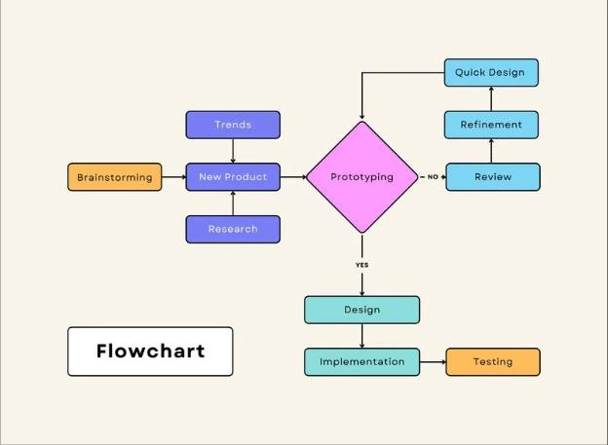

**TECHNICAL**

**ARCHITECTURE**

**:**

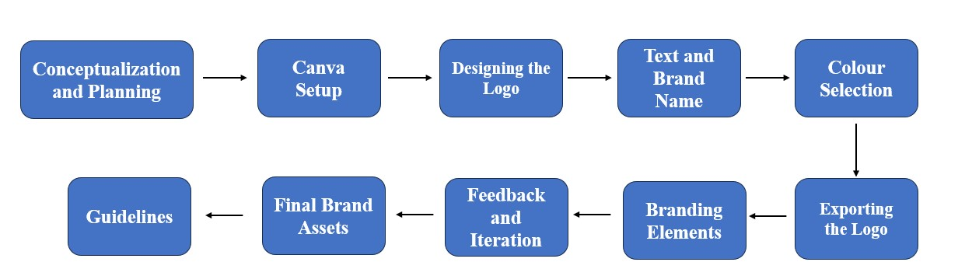

**OPEN-SOURCE FRAMEWORKS:**

**1. Brand Name:**

* **Brainstorm:** Gather a team to brainstorm potential brand names that reflect your company's values, products, or services.
* **Check Availability:** Ensure the name is unique and not already trademarked. You can use resources like the United States Patent and Trademark Office (USPTO) website.
* **Domain Availability:** Check if the corresponding domain name is available for a website.
* **Feedback:** Get feedback from stakeholders and potential customers.
* **Legal Considerations:** Consult with a legal professional to ensure your brand name is legally sound.

**2. Brand Email:**

* **Domain Name**: Choose a domain name that matches your brand. It should be professional and easy to remember.
* **Email Service Provider:** Select an email service provider, like G Suite (now Google Workspace) or Microsoft 365, for branded email hosting.
* **Setup:** Configure your branded email addresses (e.g., info@yourbrand.com) through your chosen provider.
* **Consistency:** Use your branded email for all official communication to reinforce your brand identity.

**3. Brand Logo:**

* **Define Brand Identity:** Clearly define your brand's identity, values, and target audience.
* **Hire a Designer:** Consider hiring a professional graphic designer who can bring your brand's vision to life.
* **Design Brief:** Provide the designer with a detailed design brief, including colours, typography, and any specific elements you want in the logo.
* **Review and Refine:** Review initial concepts, provide feedback, and collaborate with the designer to refine the logo.
* **Copyright:** Ensure that you have the rights to the logo and that it's not infringing on others' copyrights.

**THIRD PARTY API**

**Brand Name:**

Business Name Generators: Tools like Namelix, Brandroot, and NameMesh can generate brand name ideas based on keywords, themes, and preferences.

**Brand Email:**

**Email Service Providers (ESPs):** ESPs like Gmail for Business, Outlook, and Zoho Mail offer email services that are often used for brand emails. They provide easy setup and professional features.

**Domain Registration Services:** Services like GoDaddy and Namecheap allow you to register custom domains for your brand email, and they often offer email hosting services too.

**Brand Logo:**

**Logo Design Services:** Services like Canva, Looka (formerly Logojoy), and Wix Logo Maker provide tools and templates for creating custom logos.

**Freelance Design Platforms:** Platforms like Fiverr and 99designs connect you with professional logo designers who can create a custom logo for your brand.

**CLOUD DEPLOYMENT:**

**Brand Name:**

Your brand name is a critical part of your brand identity. It should be unique, memorable, and reflect your business or project's essence. Brainstorm ideas, consider your target audience, and research to ensure the name is available for registration.

**Branded Email:**

* To create a branded email, you'll need a domain name (e.g., yourcompany.com) and a reliable email hosting service. Many businesses use Google Workspace or Microsoft 365 for this purpose.
* Purchase a domain name through a domain registrar like GoDaddy, Namecheap, or Google Domains.
* Sign up for an email hosting service of your choice. Follow the service's instructions to set up your branded email addresses (e.g., info@yourcompany.com).

**Brand Logo:**

* Canva is a user-friendly design tool for creating logos and other brand assets. Here's how you can create a logo in Canva:
* Visit Canva's website and sign in or create an account.
* Click "Create a design" and choose "Custom dimensions" to set the logo dimensions.
* Use Canva's design tools and templates to create your logo. You can choose from a wide range of fonts, icons, and illustrations to customize your logo.
* Once you're satisfied with your logo, download it in a suitable format (e.g., PNG with a transparent background) to maintain quality.

**Cloud Deployment for Brand Assets:**

While creating your brand assets, it's important to consider where you'll store and manage them. You can use cloud services like Google Drive, Dropbox, or Adobe Creative Cloud to store and access your brand logo and other design files securely.

This ensures that your team can access and collaborate on these assets easily.

**Brand Guidelines:**

Create brand guidelines to maintain consistency in how your brand assets are used. This document should specify logo usage, colour codes, typography, and other design elements that define your brand identity.

**Implement Your Brand:**

* Once you have your brand name, branded email, and logo, start using them consistently across all your marketing materials, website, social media, and business communications.
* Remember that creating a brand name and identity is an important step in your business or project's success. Ensure that your choices are aligned with your business goals and resonate with your target audience.